Module 4 Assignment – Setting up MongoDB in Cloud

Sasanka Vepakomma

Ira A. Fulton Schools of Engineering, Arizona State University

IFT 598: Middleware Programming & Database Security

Prof. Dinesh Sthapit

Due: Oct 8, 2022

**Schema definition and datatypes for mongoDB**

Mongoose schemas are model configuration objects. Models, not schemas, are what make it possible to read and write data from MongoDB. Each schema specified in a JavaScript file corresponds to a collection in MongoDB and specifies the format of the collection's documents.

A schema helps state the properties for the documents to be inserted to the MongoDB database and define custom validations.

A Mongoose schema oversees specifying a document's structure, selecting default values, validators, etc., whereas a Mongoose model oversees specifying an interface to the database.

Some of the data types supported in MongoDB are:

* String
* Integer
* Boolean
* Double
* Min/ Max keys
* Arrays
* Timestamp
* Object
* Null
* Symbol
* Date
* Object ID
* Binary data
* Code
* Regular expression

**loanSchema.js screenshot**

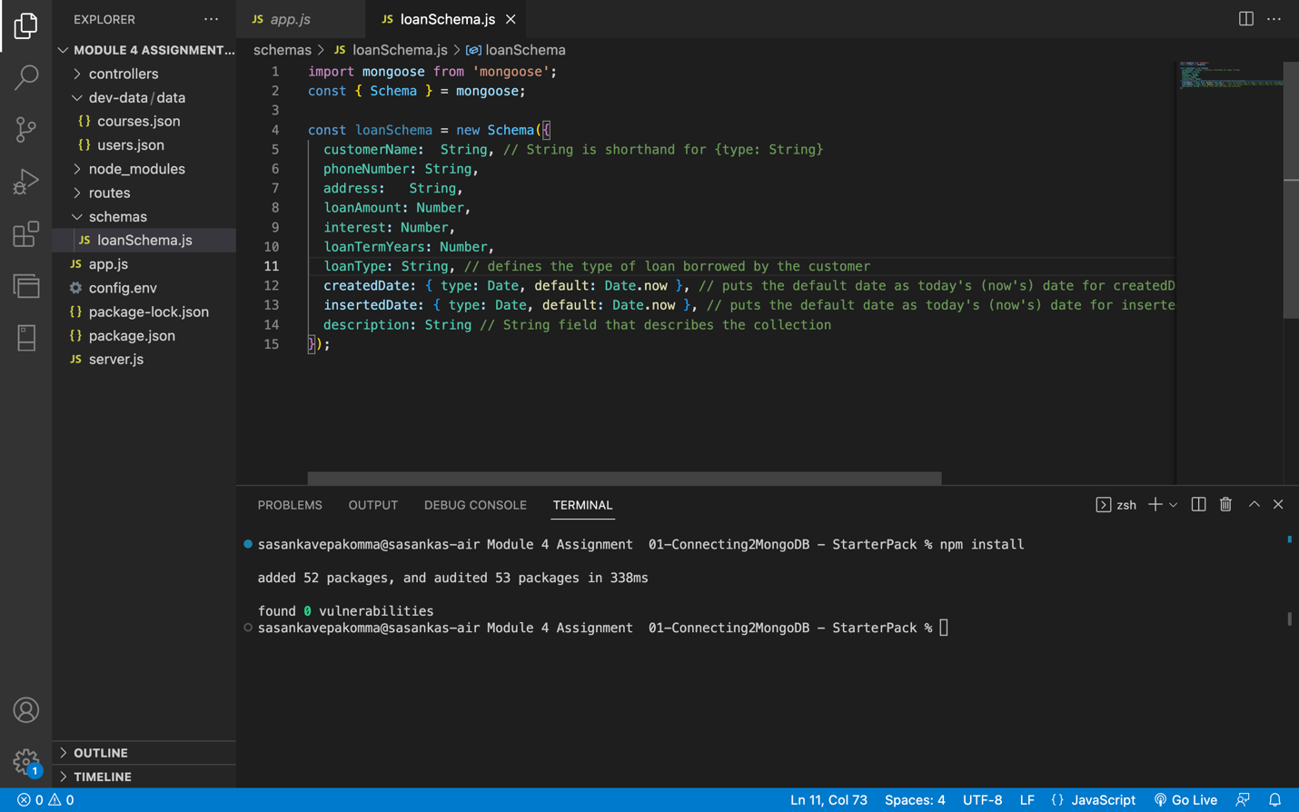

**Inserting the documents and query results screenshots**

**Github link**

<https://github.com/vsasanka/IFT598MiddlewareProg-DBSecurity/tree/main/Module%204%20Assignment%20%2001-Connecting2MongoDB%20-%20StarterPack>